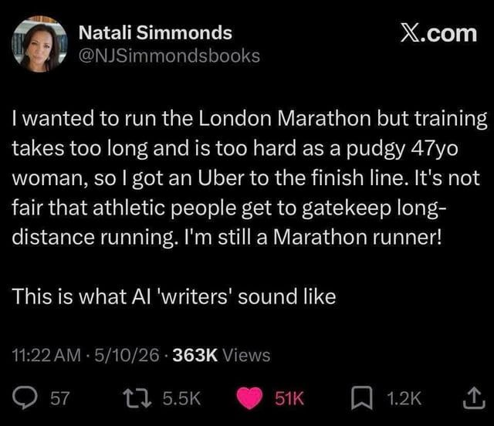
"Cut it out!"

"What?"

"The need to sound smart all the time"

"Okay, but isn't that what the world celebrates?"

"It does, but it also gets boring, really quickly"

"Why is that?"

"It is a tool, as are other modalities of processing the world around us.
The need to be celebrated for a tool limits the probabilities of what is possible with our lives".

The world celebrates Individual traits too much- Intelligence, confidence, the ability to "figure something out", to "direct", and to "shape" the world, add to it, the "high agency" bandwagon.

Folks who reach out to me inquiring about the behavioural space are usually ones with a fascination for the same tropes, with slightly higher levels of empathy.

The decoders, the analysers, the holders of "rules" that govern our world.
Folks from product, marketing, sales and academia.
Armed with AI and curiosity, ready to conquer the world- finding their place amongst the Sherlocks of the world.

But I'd come out clean and take a pause.

And ask 3 questions-

1. Who is Sherlock in a world without Watson?
2. Can Watson become Sherlock if he befriended Moriarty?
3. Would you want to be in a world where everyone is a Sherlock, working with a Moriarty?

Give it a thought, hold on to it.

Tool use and environment manipulation are not what separate our species. Baboons, raccoons, beavers and so on, do it too. You'd be surprised how good they are at it. The scales at which they can do it.

We've had access to more material to play with. We've been faced with and created more problems to solve.
We turned that ability into a "revolution" called industrialisation.

Similarly, our intelligence is not what separates us from the other species. You'd again be surprised by what a non-vertebrate with eight limbs can do when you test it for "intelligence".

We've taken our form of intelligence and put it in a box.
We celebrate that box, sell that box as the only means to be a Sherlock.

The catch?

The more "accessible" intelligence is, the blurrier the line between intelligence as a virtue and intelligence as a tool becomes.

The desire for intelligence to be celebrated came from a place of looking at it as a virtue. In that universe, stupidity was the diametric opposite.

The blurring creates a world where we've gone from "What a beautiful table" to " What a beautiful hammer this table was made with".

That's a world in love with its tools.

This democratisation of "intelligence" plays to the desire of being a Sherlock, teaming them up with the Moriarty of our creation, forgetting it was the Watson-ness in their life that gave it any meaning.

Sometimes, sitting with your stupidity and asking the universe "why" feels far more "productive".

It is time we talked about stupidity more than we celebrated intelligence.
The definitions have shifted.

AI, somehow, is both the cutting edge of Anti-Intellectualism and Anti-Stupid.

It can only be countered with Intellect, honest with its stupidity.

